**Acknowledgment**

I would like to extend my sincere gratitude to CSism Technologies for providing me with the opportunity to intern with your esteemed organization. During my internship, I had the invaluable experience of working with CSS3, HTML5, JavaScript, and PHP also SQL.

The knowledge and skills I have acquired in front-end and back-end development have significantly enhanced my understanding of web technologies. The practical experience gained through real-world projects has been instrumental in solidifying my theoretical knowledge and improving my problem-solving abilities.

I am especially thankful to my mentor, Mr. Rohit Solanki and the entire development team for their guidance, support, and encouragement. Their insights and constructive feedback have greatly contributed to my professional growth.

This internship has been a crucial step in my career development, and I am deeply appreciative of the chance to contribute to and learn from such a dynamic and innovative environment.

Lastly, I would also like to express my appreciation to CSism Technologies for the invaluable experience and support throughout my internship. The knowledge and experience gained at CSism Technologies have significantly contributed to my professional growth and understanding of web technologies.

**Abstract**

This report details my 6-week internship at CSISM Technologies, a prominent tech company dedicated to enhancing programming education for students and Software developing company. Under the guidance of CEO Mr. Ashutosh Gahiwal and MENTOR Mr Rohit Solanki, I engaged in a comprehensive learning experience focusing on HTML5, CSS3, JS, SQL and PHP. The internship provided me with hands-on exposure to web development, allowing me to deepen my technical skills and gain a thorough understanding of modern web technologies. The experience also helped me develop my communication and mentoring abilities. This report reflects on the skills acquired, the challenges faced, and the significant impact of CSISM Technologies' innovative educational approach on my professional growth.

**Introduction**

**Company Overview:**

The company CSism Technologies began as a freelance venture while its founders completed college .

In 2012, The business officially launched, starting as an institute offering coaching classes.

The institute evolved into a full-fledged software development company.

Technologies Used: HTML, CSS, JavaScript, SQL, & PHP

Founder: Mr. Ashutosh Ghaiwal  
Mentor for Internship: Mr. Rohit Solanki

Tagline of Company : “We server with Smile”



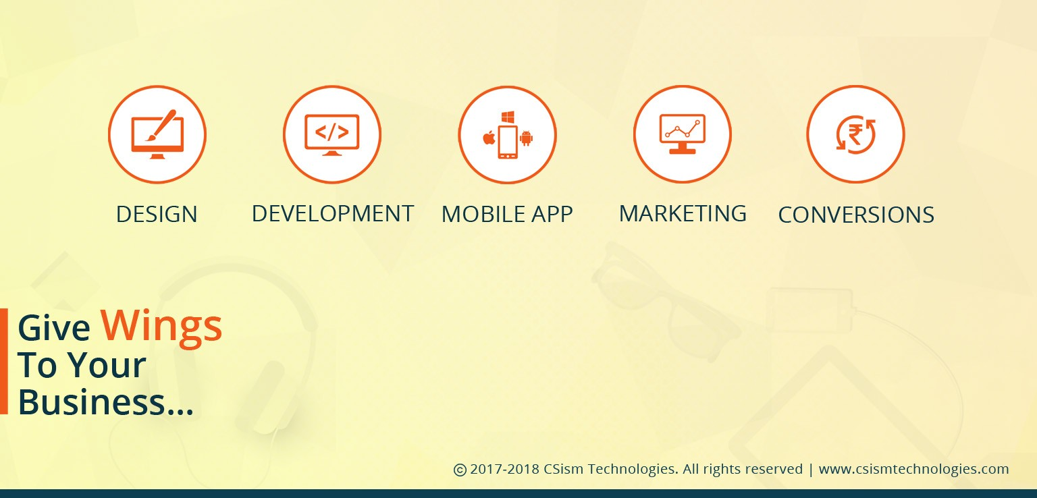

**Internship Work**

**Timeline Summary:**

During our six-week internship, we worked on building a basic e-commerce website. Our project involved creating the site's frontend using HTML, CSS, and JavaScript, and setting up the backend with PHP and SQL. We focused on designing a user-friendly and attractive interface, ensuring everything ran smoothly and efficiently. From designing the layout to handling data and transactions, we combined creativity with technical skills to develop a fully functional online platform.

**Week 01- Introduction to Web Development Basics**

* Introduction to HTML basics and creating a sample webpage.
* Learning CSS and implementing basic styling and layout structure.
* Introduction to JavaScript and implementing basic functionalities

**Week 02 - Enhancing User Interaction and Functionality**

* Implemented Owl Carousel for auto-scrolling and added Pop-Up functionality.
* Developed product details page with image zoom and add-to-cart feature.
* Designed a Contact Us page with form controls and integrated it with navigation

**Week 03 - Backend Development & Database Integration**

* Introduction to PHP and implementing backend functionalities.
* Connected Contact Us form to database; used PHP for data handling.
* Developed a Sign-Up page with form validation and database integration.

**Week 04 - Advanced Database Management**

* Implemented operations with SQL queries (update, insert, delete, select).
* Integrated database tables into the frontend with interactive features.
* Implemented Edit and Delete functionalities using PHP and JavaScript.

**Week 05 - User Interface Design & Deployment Preparation**

* Made UI enhancements based on customer feedback (font, color, style changes).
* Explored company processes and software deployment strategies.
* Added multimedia features like video pop-ups to enhance site attraction.

**Week 06 - Advanced Web Development Concepts**

* Implemented sticky header using CSS for improved navigation.
* Explored various software engineering models (e.g., Waterfall Model).
* Learned about WordPress, installed it, and created a basic site.

At last developed a basic Café E-commerce website. Using Xammp server , no use of domain instead use localhost to run it.

Throughout the internship at CSISM Technologies, I was guided by Mr. Rohit Solanki, whose mentorship made the transition from theory to practice smooth and effective. Gaining hands-on experience with HTML, CSS, PHP, SQL, and JavaScript significantly enhanced my skill set. This opportunity not only boosted my confidence but also deepened my enthusiasm for web development. The practical application of these technologies has invigorated my passion for building dynamic and functional websites.

**Project**

After completing my 6-week internship, I was ready to apply my newly acquired knowledge and skills.

Project : The project was to develop a basic E-commerce website using HTML,JS,CSS(Frontend languages) and SQL,PHP (Backend languages).

I have successfully Built up Basic Café E-Commerce website with basic things by acquiring full knowledge in each and every part of website . The website was not made so advance and not so easier it was kept basic to get basic functionality of an things around so in future we can make an advanced website using this basic things.

**It Had Features like**

1)**Advanced Database Management** : You cann edit and Delete the user at contact page in Frontend instead of Backend.

2)**Owl-Carosuel**: It is an type of slider which adds beauty to the site and attracts the customer.

3)**Bootstarp** : Makes Website Flexible as we can work on any browser and website easily.

4)**Add to Cart and Book a Event Functionality** : Instead of Calling and reserving we had booking in site itself.

And many more…..

**Tools Used**

1.**Notepad:**

HTML, CSS, and JavaScript Development: Used Notepad as an initial tool for writing and editing HTML, CSS, and JavaScript code. It provided a straightforward environment for coding and testing basic functionality.

**2. Visual Studio Code (VSCode):**

Enhanced Coding Experience: Transitioned to Visual Studio Code for a more robust development environment. Utilized features such as syntax highlighting, code suggestions, and extensions to improve productivity and code quality.

Employed VSCode’s integrated tools for color coding and text formatting, which significantly streamlined the development process and improved code readability.

**3. Browser:**

Testing and Debugging: Used web browsers (such as Chrome, Firefox) for real-time testing and debugging of web pages. Leveraged browser developer tools to inspect elements, test responsiveness, and troubleshoot issues.

**4 XAMPP Server:**

Local Server Environment- Implemented XAMPP as a local server environment to run and test PHP scripts and manage MySQL databases. This setup facilitated the development of dynamic web applications and the integration of server-side functionalities.

**Development Steps**

**Project Inception and Planning:**

* Defined the project's objective: to develop a comprehensive e-commerce website for online Café Site .
* Outlined the scope, key features, and target audience for the website.

**Design and Development:**

* Designed the database schema for product listings, user accounts, and order management.
* Used Visual Studio Code to create and refine the website's front-end using HTML, CSS, and JavaScript.
* Utilized XAAMP Server for backend development, including PHP scripting and MySQL database integration.

**Feature Implementation:**

* Applied responsive design techniques and CSS styling to enhance the overall user experience.
* User Interface Design with Visual Studio Code (VS Code)

**Testing and Deployment:**

* Conducted testing across multiple browsers to ensure compatibility and resolve layout issues.
* Utilized browser developer tools to debug and make final adjustments to the website.

**Prepared and deployed the e-commerce website to a live server, ensuring a smooth transition from development to production**

**CODE**

**Index.php (Home page HTML,CSS,JAVA)**

<?php include ('header.php');?>

<!DOCTYPE html>

<html>

<head>

    <title>Breeze Rooftop Cafe Site</title>

    <script src="https://code.jquery.com/jquery-3.5.1.slim.min.js"></script>

    <script src="https://cdn.jsdelivr.net/npm/@popperjs/core@2.5.4/dist/umd/popper.min.js"></script>

    <script src="https://stackpath.bootstrapcdn.com/bootstrap/4.5.2/js/bootstrap.min.js"></script>

    <link rel="stylesheet" type="text/css" href="style.css">

    <link rel="stylesheet" type="text/css" href="xx.css">

    <style>

        body, html {

            margin: 0;

            font-family: Arial, sans-serif;

        }

        .w3-container {

            text-align: center;

        }

        .w3-modal {

            display: flex;

            justify-content: center;

            align-items: center;

            position: fixed;

            top: 0;

            left: 0;

            width: 100%;

            height: 100%;

            background-color: rgba(0, 0, 0, 0.5);

            z-index: 1000;

        }

        .w3-modal-content {

            animation: zoom 0.6s;

            background: #fff;

            padding: 20px;

            border-radius: 5px;

            max-width: 50%; /* Adjust the max-width to control video size */

        }

        .w3-modal-content video {

            width: 100%;

            border-radius: 5px;

        }

        @keyframes zoom {

            from {transform: scale(0)}

            to {transform: scale(1)}

        }

        #slider {

            overflow: hidden;

        }

        #slider figure {

            position: relative;

            width: 500%;

            margin: 0;

            left: 0;

            animation: slider 20s infinite;

        }

        #slider figure img {

            float: left;

            width: 20%;

        }

        @keyframes slider {

            0% { left: 0; }

            20% { left: 0; }

            25% { left: -100%; }

            45% { left: -100%; }

            50% { left: -200%; }

            70% { left: -200%; }

            75% { left: -300%; }

            95% { left: -300%; }

            100% { left: -400%; }

        }

        nav {

            background-color: #333;

            overflow: hidden;

        }

        nav img {

            height: 50px;

            margin: 10px;

            float: left;

        }

        nav a {

            display: block;

            color: white;

            text-align: center;

            padding: 14px 20px;

            text-decoration: none;

            float: left;

        }

        nav a:last-child {

            float: right;

        }

        footer {

            text-align: center;

            padding: 20px;

            background: #222;

            color: #fff;

        }

        footer a {

            color: #009688;

            text-decoration: none;

            margin: 0 10px;

        }

        footer a:hover {

            text-decoration: underline;

        }

        footer .social-icon {

            width: 20px;

            height: 20px;

            margin: 0 10px;

            vertical-align: middle;

        }

        .review-button {

            background-color: #ffc107;

            color: #1a1a2e;

            padding: 10px 20px;

            border: none;

            border-radius: 5px;

            font-size: 1em;

            cursor: pointer;

            margin-top: 10px;

            display: block;

            margin: 0 auto 20px auto;

        }

        .review-button:hover {

            background-color: #e0a800;

        }

        .popup {

            display: none;

            position: fixed;

            top: 50%;

            left: 50%;

            transform: translate(-50%, -50%);

            background-color: #fff;

            padding: 20px;

            border-radius: 10px;

            box-shadow: 0 4px 8px rgba(0, 0, 0, 0.1);

            width: 300px;

            text-align: center;

            z-index: 1000;

        }

        .popup .close-button {

            background-color: #e0a800;

            color: #1a1a2e;

            padding: 5px 10px;

            border: none;

            border-radius: 5px;

            font-size: 0.8em;

            cursor: pointer;

            margin-top: 10px;

        }

        .overlay {

            display: none;

            position: fixed;

            top: 0;

            left: 0;

            width: 100%;

            height: 100%;

            background: rgba(0, 0, 0, 0.7);

            z-index: 999;

        }

    </style>

</head>

<body>

<div id="slider">

    <figure>

        <img src="IMG1.jpg" alt="Slide 1">

        <img src="IMG2.jpg" alt="Slide 2">

        <img src="IMG3.jpg" alt="Slide 3">

    </figure>

</div>

<hr height="200" color="black">

<h1 style="text-align: center;">Our Speciality</h1>

<section class="product">

    <button class="pre-btn"><img src="images/arrow.png" alt=""></button>

    <button class="nxt-btn"><img src="images/arrow.png" alt=""></button>

    <div class="product-container">

        <div class="product-card">

            <img src="f1.jpg" alt="Image 1" height="400" width="300">

        </div>

        <div class="product-card">

            <img src="f2.jpg" alt="Image 2" height="400" width="300">

        </div>

        <div class="product-card">

            <img src="f3.jpg" alt="Image 3" height="400" width="300">

        </div>

        <div class="product-card">

            <img src="f4.jpg" alt="Image 4" height="400" width="300">

        </div>

        <div class="product-card">

            <img src="f5.jpg" alt="Image 5" height="400" width="300">

        </div>

        <div class="product-card">

            <img src="f6.jpg" alt="Image 6" height="400" width="300">

        </div>

        <div class="product-card">

            <img src="f7.jpg" alt="Image 7" height="400" width="300">

        </div>

        <div class="product-card">

            <img src="f8.jpg" alt="Image 8" height="400" width="300">

        </div>

        <div class="product-card">

            <img src="f9.jpg" alt="Image 9" height="400" width="300">

        </div>

        <div class="product-card">

            <img src="f10.jpg" alt="Image 10" height="400" width="300">

        </div>

        <div class="product-card">

            <img src="f11.jpg" alt="Image 11" height="400" width="300">

        </div>

        <div class="product-card">

            <img src="f12.jpg" alt="Image 12" height="400" width="300">

        </div>

    </div>

</section>

<div class="w3-container">

    <div id="modal01" class="w3-modal" onclick="this.style.display='none'">

        <span class="w3-button w3-hover-red w3-xlarge w3-display-topright">&times;</span>

        <div class="w3-modal-content w3-animate-zoom">

            <video controls>

                <source src="video.mp4" type="video/mp4">

                Your browser does not support the video tag.

            </video>

        </div>

    </div>

</div>

<!-- Review Button Section -->

<div class="review-section">

    <button class="review-button" onclick="openPopup()">Leave a Review</button>

</div>

<div class="overlay" id="overlay"></div>

<div class="popup" id="popup">

    <h2>Leave a Review</h2>

    <iframe src="review.php" style="border:0; width:100%; height:300px;"></iframe>

    <button class="close-button" onclick="closePopup()">Close</button>

</div>

<script src="javacs.js"></script>

<script>

    let slideIndex = 0;

    showSlides();

    function showSlides() {

        let i;

        let slides = document.getElementsByClassName("mySlides");

        for (i = 0; i < slides.length; i++) {

            slides[i].style.display = "none";

        }

        slideIndex++;

        if (slideIndex > slides.length) {slideIndex = 1}

        slides[slideIndex-1].style.display = "block";

        setTimeout(showSlides, 2000); // Change image every 2 seconds

    }

    function openPopup() {

        document.getElementById("popup").style.display = "block";

        document.getElementById("overlay").style.display = "block";

    }

    function closePopup() {

        document.getElementById("popup").style.display = "none";

        document.getElementById("overlay").style.display = "none";

    }

</script>

<?php include ('footer.php');?>

</body>

</html>

**Header.php**

<header>

 <nav>

        <img src="logo.jpg" alt="Cafe Logo">

        <a href="index.php">Home</a>

        <a href="menus.php">Menus</a>

        <a href="contactus.php">Contact Us</a>

        <a href="event.php">Event</a>

        <a href="studio.php">Culinary Studio</a>

        <a href="signup.php" target="_blank">Login/Sign in</a>

    </nav>

</header>

**Database connection Code**

**Database.php**

<?php

$servername = "localhost";

$username = "root";

$password = "";

$database = "contact";

// Create connection

$conn = new mysqli($servername, $username, $password, $database);

if ($conn->connect_error) {

  die("Connection failed: " . $conn->connect_error);

}

echo "Connected successfully";

?>

**Contact_back.php**

<?php

include('database.php');

$servername = "localhost";

$username = "root";

$password = "";

$dbname = "pranjal_20";

$conn = new mysqli($servername, $username, $password, $dbname);

if ($conn->connect_error) {

    die("Connection failed: " . $conn->connect_error);

}

if ($_SERVER['REQUEST_METHOD'] === 'POST') {

    $id = $_POST['id'];

    $name = $_POST['name'];

    $email = $_POST['email'];

    $mobile = $_POST['mobile'];

    $message = $_POST['message'];

    if (empty($id)) {

        // Insert new record

        $sql = "INSERT INTO contactform (name, email, mobile, message) VALUES ('$name', '$email', '$mobile', '$message')";

    } else {

        // Update existing record

        $sql = "UPDATE contactform SET name='$name', email='$email', mobile='$mobile', message='$message' WHERE id=$id";

    }

    if ($conn->query($sql) === TRUE) {

        header("Location: contactus.php?success=true");

    } else {

        echo "Error: " . $sql . "<br>" . $conn->error;

    }

}

$conn->close();

?>

**And many more codes……………**

**Outputs**

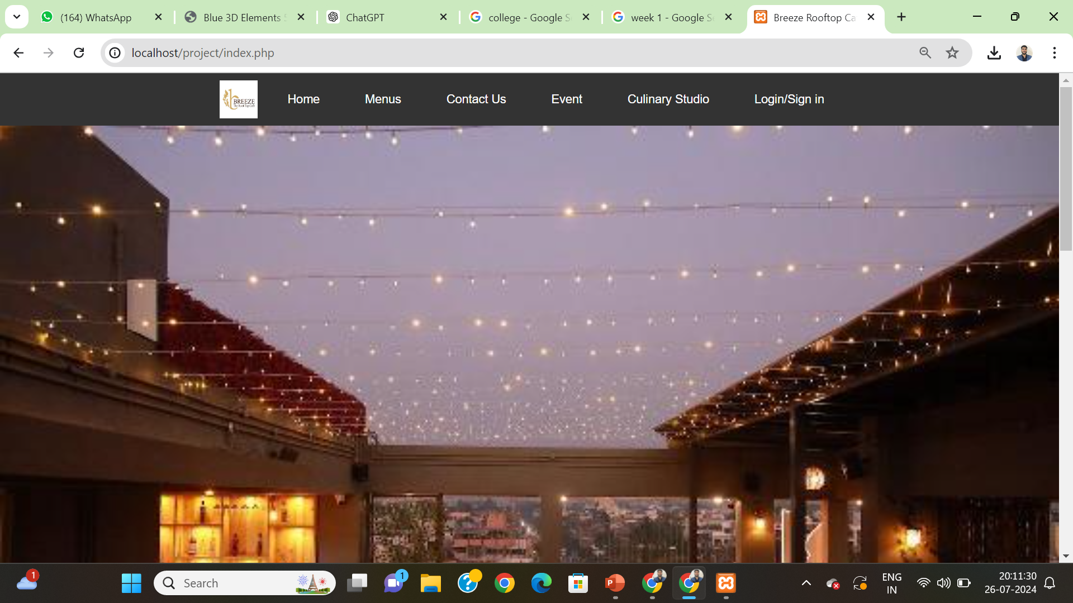

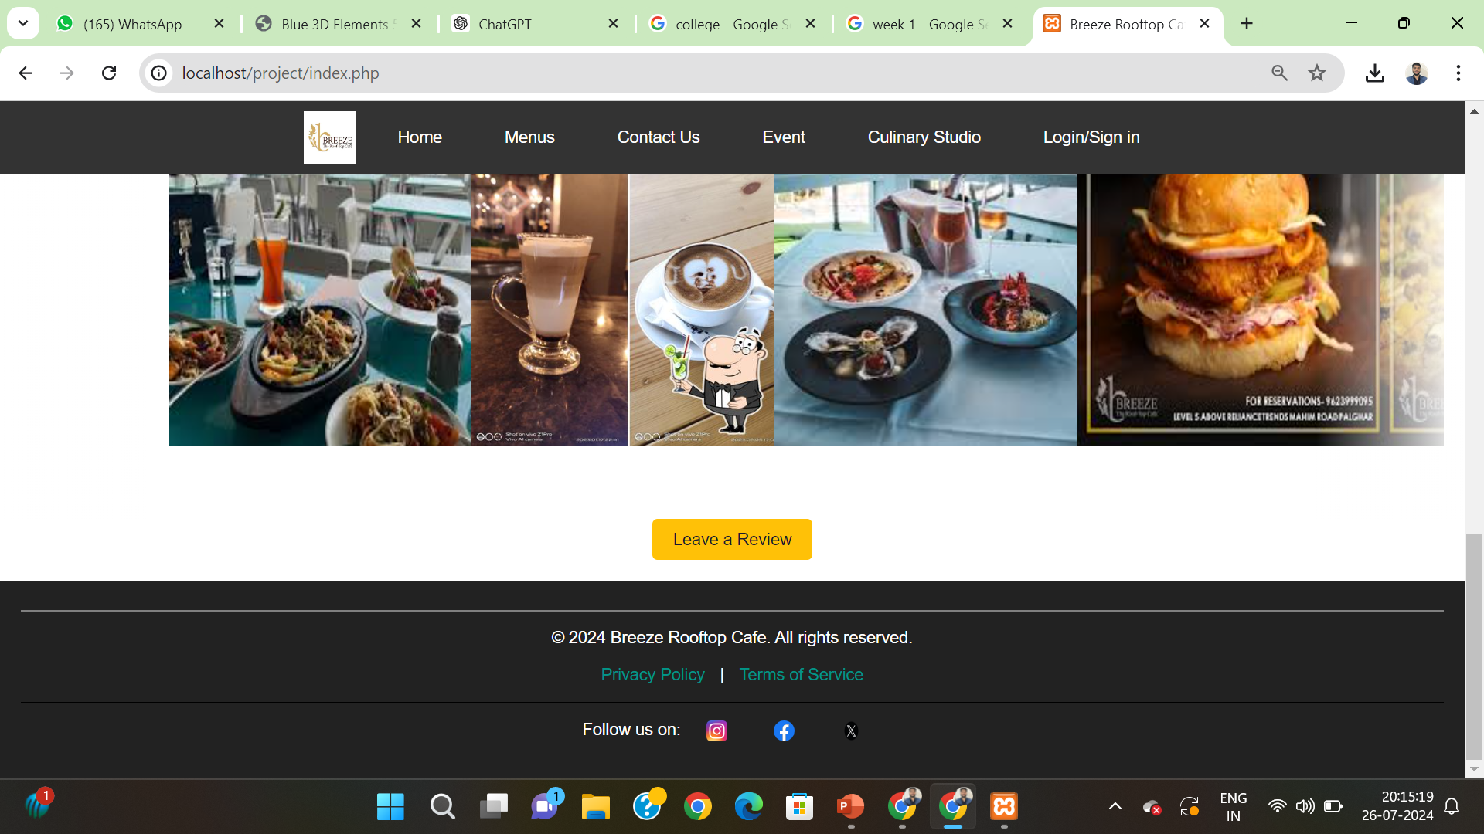

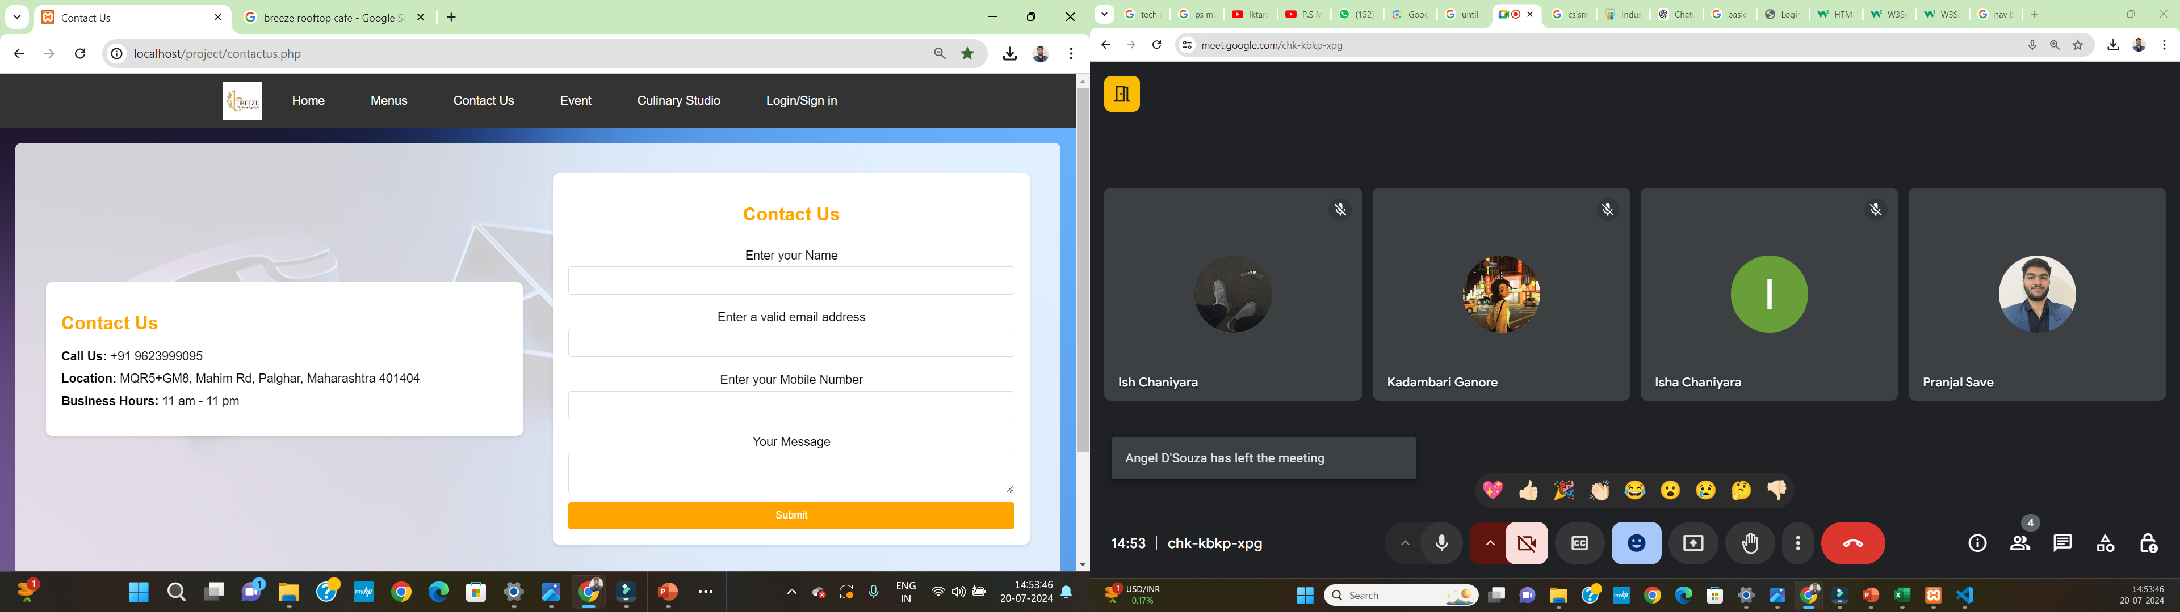

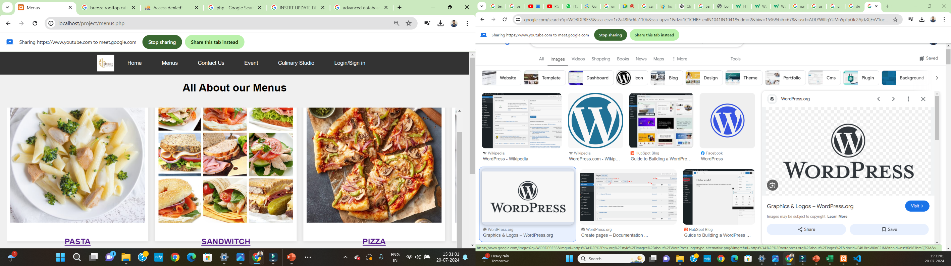

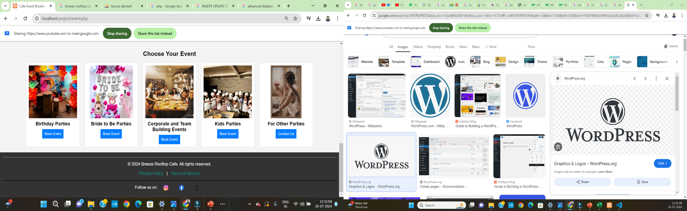

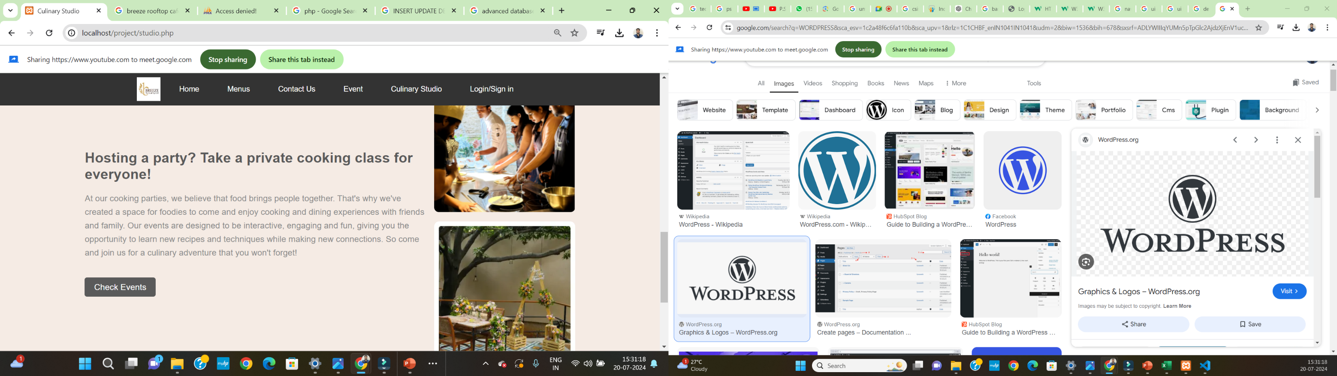

**Conclusion**

My six-week internship at CSISM Technologies has been a transformative experience, allowing me to apply and expand my knowledge in web development. Under the expert guidance of Mr. Rohit Solanki and the support of the entire development team, I gained valuable hands-on experience with HTML5, CSS3, JavaScript, PHP, and SQL.

The internship provided me with a comprehensive understanding of both frontend and backend development. I successfully built a basic café e-commerce website, integrating features such as advanced database management, interactive carousels, and user-friendly booking functionalities. This project not only solidified my technical skills but also enhanced my problem-solving abilities and deepened my passion for web development.

Working with tools like Visual Studio Code and XAMPP, and learning to manage real-world challenges, has greatly contributed to my professional growth. The insights and feedback from my mentors were invaluable, and the opportunity to work on practical projects has significantly boosted my confidence and enthusiasm for programming.

Overall, this internship at CSISM Technologies has been a pivotal step in my career, equipping me with practical skills and a deeper understanding of web technologies. I am grateful for the opportunity and excited to apply what I've learned in future projects.

**Certification**

